IS 350—Professor Mark G. Simkin The Visual Basic Casino

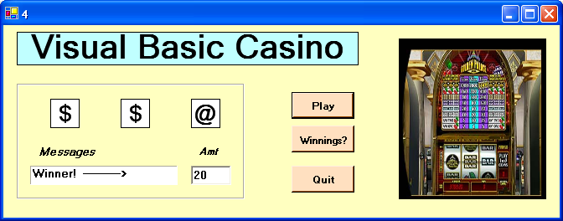

Objective: The objective of this assignment is to create a user interface that simulates the workings of a casino slot machine. This assignment requires a good understanding of form-level variables and selection code.

Description: Most modern slot machines these days are electronic, even if the wheels are mechanical. There are several advantages of all-electronic slot machines—for example, they do not wear out as fast and they are harder to cheat. The interface for this assignment is shown above. It uses labels for the text symbols (instead of cherries or bells), but winning is basically the same as on real machines: if two or more symbols match, the player wins something. If not, the player loses. Please use the following symbols for this assignment: $, #, @, %, *.

There are three buttons for this interface. When the user clicks on the Play button, the system first validates the amount in the Amt textbox. If this amount is blank, zero, or negative, the system displays a message box that alerts the user to an invalid amount and does not allow play to continue. Otherwise, the system selects random symbols for each of the three “reels,” and computers the user’s winnings.

The system computes winnings as follows. If all three reels match, the user wins three times his or her bet. If two of the three reels match, the user wins twice his or her bet. If none of the reels match, the user loses his or her bet.

The system keeps a running tally of the total amount won or lost. When the user clicks on the “Winnings?” button, the system displays the running total in the Amt textbox. Finally, if the user clicks on the Quit button, the system ends execution.

Hints: You can use Visual Basics RND function to compute a random number between 0 and 1. You will need to generate a separate such number for each reel. If the system generates a value between 0 and .2, you can assign the reel the symbol “$,” if the system generates a value between .2 and .4 you can assign the reel the symbol “#,” and so forth.

